Review Guide for AP US Govt. and Politics Exam

Constitutional Underpinnings
Political Beliefs and Behaviors
Political Parties, Interest Groups, and Mass Media
Institutions of the Government (Legislative Branch, Executive Branch)
Public Policy
Judicial Branch, Civil Rights, and Civil Liberties
Constitutional Underpinnings of the U.S. Government
- Concepts of American Democracy
  - In a democracy, ordinary citi8zens wield the power to government. The U.S. is a hybrid combining many different types of democracy.
    - Direct Democracy- all citizens participate in the lawmaking process.
    - Representative Democracy (i.e. republican democracy) - citizens elect representatives to do the lawmaking.
    - The U.S. is a Constitutional democracy which means the powers of government are limited by a written constitution.
  - Features of American political culture:
    - Natural law, consent of the governed, distrustful of government (prevents encroachment of individual liberties), political equality.
  - Americans have a low level of participation in government. Majority of electorate does NOT vote.
  - Know: Pluralist, Elitists, and Hyperpluralists Theories
- Constitution
  - Articles of Confederation replaced by the Constitution to create a stronger national government. (weaknesses included no power to tax or regulate trade, as well as preventing the formation of a unified nation because individual states had too much power)
    - Shay’s rebellion was the final straw in proving the Articles were not a sufficient plan for the government under the Articles. (illustrates the importance of property rights to the founders)
  - Final structure of the Constitution

    - Article I: Legislative Branch
    - Article II: Executive Branch
    - Article III: Judicial Branch
    - Article IV: Federalism
    - Article V: Amendment Process
    - Article VI: Supremacy Clause
    - Article VII: Ratification Procedures

  - 2 Principles of the Constitution (according to the Madisonian Model): Separation of Powers and Checks and Balances
    - Legislative Checks

      - House and Senate can veto a bill of the other house
      - Senate approves presidential nominations for judges and other officials,
      - Can impeach the president
      - Controls the budget
      - Can pass laws over a president’s veto with a two-thirds majority.

    - Executive Branch
      - Can veto bills passed by Congress
      - Nominates judges and other government officials.
    - Judicial Branch
      - Can declare laws passed by Congress to be unconstitutional
      - Can declare acts of the president to be unconstitutional (not asserted until Marbury v. Madison in 1803)
  - Amendment Process
    - Proposal: By Congress with a 2/3 vote in each House or by National Convention called by 2/3 of states
    - Ratification: By ¾ of state legislatures or by Conventions in ¾ of the states.
  - The amendment process is a reflection of our federal system of government.
  - The Informal Process of Constitutional Change

    - Judicial Interpretation
    - Marbury v. Madison (1803): judicial review
    - Changing Political Practice
    - Technology
    - Increasing Demands on Policymakers

  - Our nation has become more democratic over time through formal and informal amendments
    - Example: in areas of significant linguistic minorities, voting materials must be made available in the preferred language of the population.
  - Federal Government has become more powerful over time. The necessary and proper clause (Article 1, Section 8) has been used to expand the power of the Federal Government (elastic clause). Most of the expansion of the federal government has been justified using the commerce clause, beginning with McCullough v. Maryland in 1819 and furthered by Gibbons v. Ogden in 1824.
- Federalism
  - Understand Dual vs. Cooperative. Unitary Governments, Confederation, enumerated, reserved, concurrent powers, Supremacy Clause
  - Decentralization of Government results in: opportunities for political participation at all levels (local, state, and federal representatives), greater public involvement through electing local, state, and federal representatives, greater access to government because a number of concerns can be represented across all levels, Decisions can be made at lower levels allowing the federal government to concentrate on fewer issues, parties functioning at two levels, and increases the importance of intergovernmental relations because of elaborate communication necessary to share power.
  - The 10th Amendment to the Constitution has been interpreted by the Supreme Court to reserve powers to the states
  - Full faith and credit clause requires each state to formally recognize documents and judgments handed down by courts in other states.
  - Privileges and Immunities Clause helps unify the states by assuring all citizens are treated equally when they travel from state to state.
  - Fiscal federalism (Cooperative Federalism=categorical grants, block grants, mandates, cross-cutting requirements, cross over sanctions, etc…)
    - Generally, the federal, state, and local governments work together to complete a project, with the federal government providing much of the project funding.
    - Trends: Federal Grants to state and local governments have increased since 1950. After 1980, grants decreased as a percentage of federal outlays as part of the trend of devolution, which employed more block grants.
Possible FRQ’s for Constitutional Underpinnings
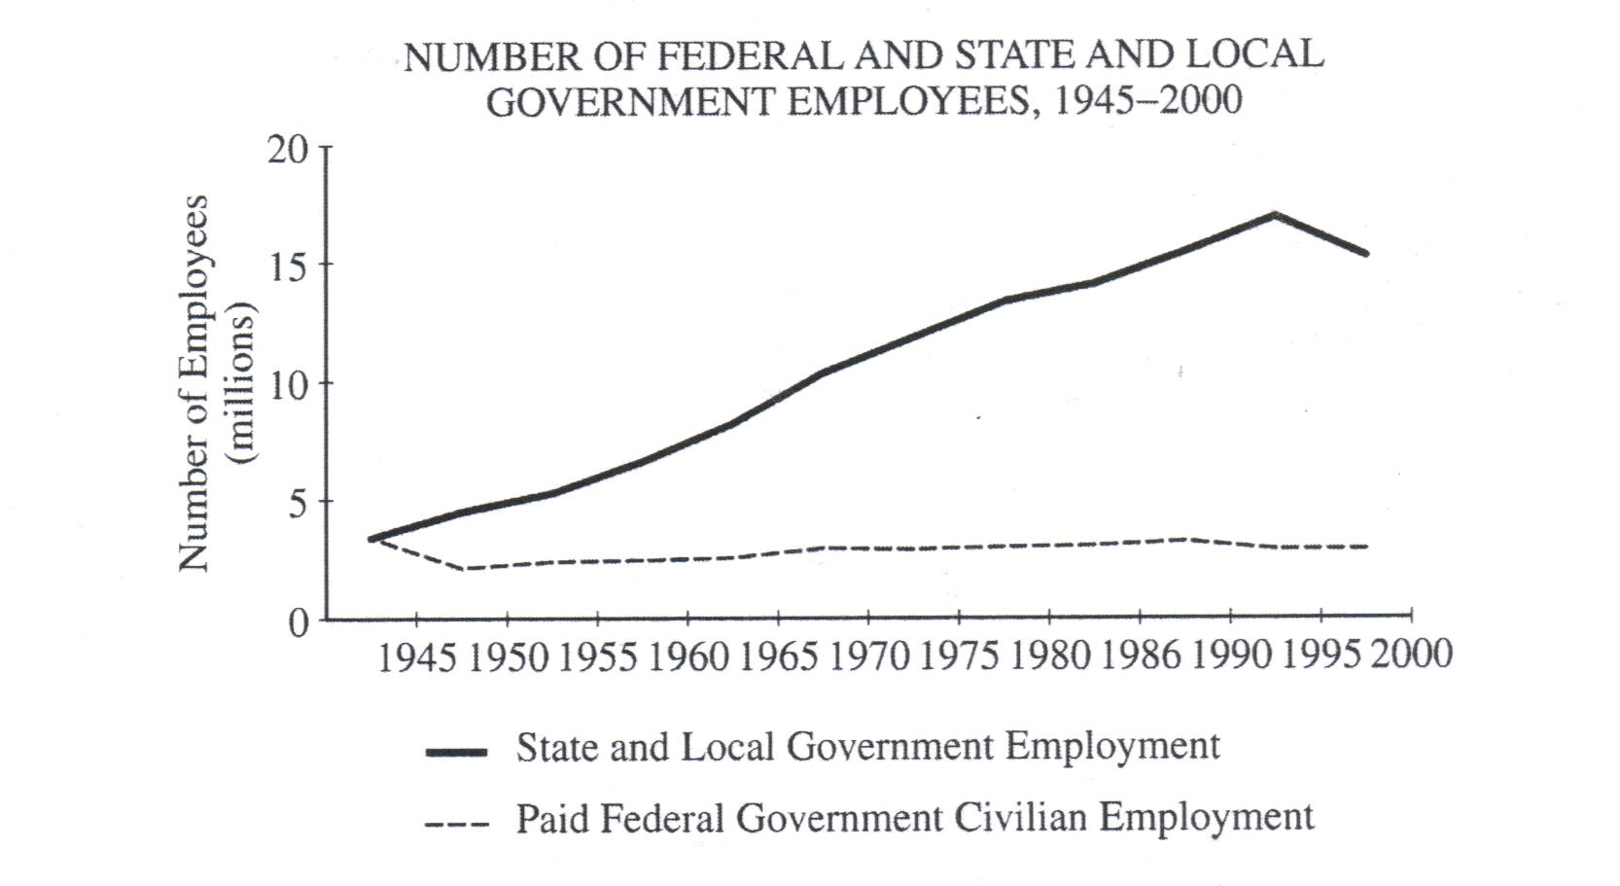

- Using the data in the graph above and your knowledge of United States politics, perform the following tasks.
- Identify two trends shown in the graph.
- Explain how each of the following contributes to the difference between the federal and the state and local lines in the graph.
- Block Grants
- Federal Mandates
- The power of the federal government relative to the power of the states has increased since the ratification of the Constitution.
- Describe two of the following provisions of the constitution and explain how each has been used over time to expand federal power.
- The power to tax and spend
- The “necessary and proper” or “elastic” clause
- The commerce clause
- Explain how one of the following has increased the power of the federal government relative to the power of state governments.
- Americans with Disabilities act
- Civil Rights Act of 1964
- Clean Air Act
- A significant feature of the Electoral College is that most states have a winner-take-all system.
a) Describe the winner-take-all feature of the Electoral College.
b) Explain one way in which the winner-take-all feature of the Electoral College affects how presidential candidates from the two major political parties run their campaigns.
c) Explain one way in which the winner-take-all feature of the Electoral College hinders third-party candidates
d) Explain two reasons why the Electoral College has not been abolished.

- The framers of the United States Constitution created a federal system.
- Define federalism
- Select two of the following and explain how each has been used to increase the power of the federal government relative to the states.
- Categorical grants
- Federal mandates
- Selective incorporation.
- Select two of the following and explain how each has been used to increase the power of the states relative to the federal government.
- Welfare Reform Act of 1996
- Block grants
- Tenth Amendment
- Pluralist theory, Elite/Class Theory, and Hypluralism are three competing views of American politics.
a. Describe two ideas associated with pluralist theory.
b. Describe two ideas associated with elite/class theory
c. Describe two ideas associated with Hypluralism
d. Which on of the theories best characterizes American government? Support your argument by providing two reasons why the theory you have chosen best characterizes American government.

- When James Madison proposed a new constitution, he tried to balance the need for "proper energy" in government with a clear limitation on government power as well.
a. Identify two features Madison proposed for keeping any branch of government from becoming too powerful.
b. explain how each feature identified in A. balances the need for strong government with a need for limited government. Use two examples to support your answer.
c. Identify one feature Madison proposed for dividing powers between national and state governments.
d. explain how this feature balanced the need for a strong central government while assuring the states of adequate power.

Principles from released FRQ’s Constitutional Underpinnings
- Federalism: a way of organizing a nation so that two or more levels of government have formal authority over the same area and people.
- Categorical grant: Grant designed for a specific purpose, States must spend money in accordance with government’s wishes.
- Federal mandate: a federal government tells states what policies to implement. Often, funds are not provided to support these mandates (unfunded mandate)
- Selective incorporation: Federal courts can overturn state and local practices. This has been done slowly, over time.
- Welfare Reform Act of 1996 include: States were given the power and money to run their own welfare program. States were given discretion to determine how to implement the federal goal of transferring people from welfare to work. Part of a larger movement of devolution, or giving power back to the states.
- Block grants include: It is targeted money, block grants to states have few strings attached, so states can make decisions about the details of where the money goes.
- Tenth Amendment: It reserves power to the states and to the people, It is being used to argue that power be returned to the states.
- Pluralist Theory: A theory of government and policies emphasizing that politics is mainly a competition among groups, each one pressing for its own preferred policies, Groups will work together, Public interest will prevail through bargaining and compromise
- Elite and Class Theory: A theory of government and politics contending that societies are divided along class lines and that an upper-class elite will rule, regardless of the formal niceties of governmental organization, Not all groups equal, Policies benefit those with money and power
- Hyper pluralism: A theory of government and politics contending that groups are so strong that government is weakened, Groups control policy and prevent government from acting, Difficulty in coordinating policy implementation, Confusing and contradictory policies result from politicians trying to placate every group
- Acceptable explanation for separation of powers include: Power is divided among three branches of government-the legislative, executive, and judicial, Each branch has a specific grant of power and each is independent of the other
- Examples of separation of powers
  - Legislative Branch: Made up of the House of Representatives and the Senate. The House and Senate can veto each other’s bills.
  - Executive Branch: Executive Office of the President, Executive and Cabinet level departments, and independent government agencies. “faithfully execute the Constitution of the United States.”
  - Judicial Branch: Supreme Court, courts of appeal, and district courts.
- Acceptable explanation for checks and balances: setting power against power to constrain government actions.
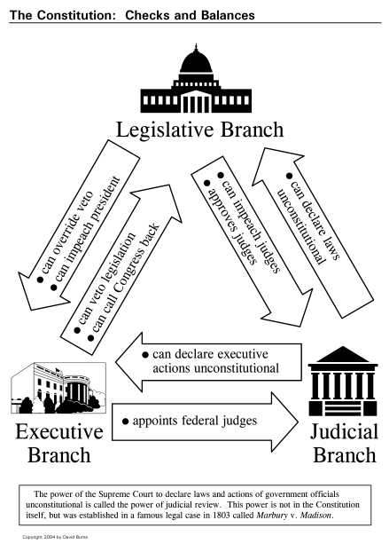
- Examples of checks and balances:

- Federalism is a way to keep government from getting too much power
- How does federalism keep government from getting too much power while assuring that states have power?
  - Powers of the national government are listed in Article I.
  - Powers reserved to the state governments are those not listed in Article I. The Tenth Amendment specifies this.
  - As a result of these specific powers, the Constitution hoped to prevent the federal government from becoming too strong.
  - Until the 1980’s, the trend has been for the federal government to gain more power
  - Recently, devolution has attempted to give more power back to the states, beginning with Ronald Reagan.
- Tax and spend power
  - Who exercises this power? (Congress/national govt.)
- The “necessary and proper” or elastic clause
  - Who exercises this power ?(Congress/national govt.)
  - Must describe the power to pass laws
- The commerce clause
  - Who exercises this power? (Congress/national govt.)
  - Must refer to the regulation of interstate commerce, foreign commerce/trade, or commerce with native American tribes.
- The federal government uses these three powers to expand the power of the federal government by: grants from the national government to the state government for specific purposes and with strings attached. When given a categorical grant, states agree to spend the money in specific ways.
  - Possible examples include:
    - Interstate Highway Act
    - Federal Mandate to Raise the Drinking Age to 21
- Advantages of categorical grants include: Allows the national government to have greater fiscal responsibility for the money that it collects; Members of Congress may feel responsible for money collected therefore they exercise specific control over how it is spent.
- Disadvantages of categorical grants include: States can be “blackmailed” by the national government.
- Block grants are moneys given by the national government to the states for more general purposes. States often, have choices to make on how to spend block grants.
- Examples of Block Grants include: Different regions having different needs, Welfare Reform Act of 1996
- Advantages of Block Grants: It allows the states the ability to use money specific to the needs of the states, It empowers the states to have more control over how money is spent.
- Disadvantages of Block Grants: National government does not have much control over the money and states may waste it.

Political Beliefs and Behaviors
- Beliefs (key terms): Political Socialization , Political Ideology, Political efficacy (see Ch. 10), Divided government
  - Factors influencing political socialization: family, mass media, school, religion. Takes place over one’s entire life with family being the most important influence.
  - Americans are strongly individualistic.
  - Americans have a low sense of trust in government since the 1950’s.
  - Americans strongly believe in the following core values: legal and political equality; freedom of religion and speech (NOT economic equality)…However, Americans are not tolerant of those they disagree with.
  - Public opinion polls. Know: random sample, sampling error, exit polls.
  - Political Ideologies:
    - Conservatism favors limited government and greater freedom in the private sector. More likely to support military spending, free markets, prayer in school, and reduced taxes. Opposes abortion, affirmative action, and government spending on social programs.
    - Liberalism favors an active central government with social and economic responsibilities, a more equal distribution of wealth, more government regulation of bug business, more government spending on social programs, and abortion. Opposes increases in defense spending and military actions, prayer in school, and tax breaks for the wealthy.
- Behaviors
  - Know: Suffrage, 15th, 19th, and 26th Amendments, Motor Voter Act,
  - Forms of participation (voting, protest, grassroots campaigns, civil disobedience, join a political party/interest group, donate $, community service). Voter turnout has been on the decline in the past few decades while campaign contributions have been on the rise.
  - Obstacles to participation (voter registration, apathy, extension of suffrage, ineffectiveness of political parties).
  - Demographics:

    - Age- older voter, more likely to vote, but drops off after getting too old.
    - Education: More education = more likely to vote and be politically active. Most important factor
    - Religious
    - High income
    - Race – African American, Hispanic, and Asian (most unrepresented groups of American voters)
    - Gender: Female = more likely to vote
    - Marital Status: Married = more likely to vote
    - Union Membership: Union member = more likely to vote
    - Traits are cumulative– possessing several adds up

  - Psychological Factors:
    - Partisans more likely to vote than independents, those who has political efficacy (belief that their vote matters), and those who believe it is a good citizen’s civic duty to vote.
  - Democrats have a new, strong coalition of voters (young, Hispanics and other minorities, white upper-class professionals)
  - What determined who people vote for? Political party most important factor in determining how people vote. Also, candidates personalities (based on integrity, competence, and reliability), and policy preferences.
  - Voter turnout is the percentage of population that votes. Turnout is 50% for presidential elections, and 35% for congressional elections. This is down from the 1960s, when compared with voter turnout in other democracies, Americans rank near the bottom.
Possible FRQ’s for Political Beliefs/Behaviors
- Over the last half of the twentieth century, voter turnout in federal elections has declined. During the same period, voter turnout has been higher in presidential elections than in midterm elections.
a) Identify two factors that have contributed to the overall decline in turnout in federal elections and explain how each factor has contributed to the overall decline.
b) Identify and explain two reasons why voter turnout has been higher in presidential elections than in midterm elections.

- Citizens often choose to participate in the political process in ways other than voting.
a) Identify two forms of participation in the political process other than voting.
b) Explain two advantages of each form of participation you identified in (a).

- Trust and confidence in government have declined in recent decades.
a) Explain how divided government has contributed to the decline in trust and confidence in government. Be sure to include a definition of divided government in your response.
b) Explain how the increased cost of election campaigns has contributed to the decline in trust and confidence in government.
c) Explain two specific consequences of the decline in trust and confidence in government for individual political behavior.

- In the United States political system, there are several linkage institutions that can connect citizens to government. Elections constitute one such institution. Because of lower voter turnout, elections represent an imperfect method of linking citizens to their government. Even when there is low voter turnout, however, other linkage institutions can connect citizens to government.
- Describe how each of the following is related to the likelihood of voting
- Age
- Education
- Identify one current government electoral requirement that decreased voter turnout. Explain how it decreases voter turnout
- Identify one linkage institution other than elections and explain two ways it connects citizens to government.

Principles Drawn from Released MC’s and FRQ’s (Political Beliefs and Behaviors)

- The voter turnout rate in the United States is usually lower than Western democracies
- The higher one’s socioeconomic status, the greater the probability of active involvement in the political process.
- Any issue that produces “cross-pressure” reduces turnout. Example: In 1980, Democrats shared Ronald Reagan’s views on taxation and Republican women who opposed party platform on Equal Rights Amendment (ERA) both turned out in low rates.
- The more frequent a person has voted in the past, the more likely, he or she is to vote in the current election. This explains why expanding suffrage has not increased voter turnout over time.
- American political culture is characterized by a strong popular support for equality of opportunity (the “American Creed”)
- Men and women vote at relatively equal proportions.
- During the past twenty-five years, all of the following changes in political opinion and political behavior has occurred in the U.S: decline in level of trust in government, drop in voter turnout, increase in ticket splitting, and erosion of party loyalties, especially among young people.
- Black Americans voted most heavily Democratic in presidential elections between 1964 and 1992.
- The most common form of political activity undertaken by U.S. citizens is voting in presidential elections.
- The majority of Americans agree in principle with rights of freedom of speech and assembly but are, typically, intolerant of views they do not support.
- Americans have seen a significant decline in trust in their government since the 1950’s.
- The most important criteria people use when voting for a presidential candidate is the candidate’s party identification.
- People with high incomes are more likely to think of themselves as conservative than those of lower incomes.
- Political socialization is the process by which political values are passed to the next generation.
- Individuals trust in government has declined for each of the following reasons: We live in an era of “divided government”, which means that one party controls the Congress while another controls the White House, frustration with the government process, heightened partisan atmosphere, “bowling alone”, and often, the confirmation process has been slowed, stopped, or circumvented.
- The following are ways individuals can participate in the political process: Conventional methods: voting, working on a campaign, contacting elected officials, protest: a form of political participation designed to achieve policy changes through dramatic and unconventional tactics, grass roots campaigns encourage citizens to get out and vote. Civil disobedience, joining an interest group or political party, donate money to a campaign, and community service.
- Voting patterns: older people are more likely to vote, turnout is lowest for young people, the likelihood of voting declines in the oldest populations.
- Voting in the U.S. is more difficult than in other Western Democracies.

Political Parties, Interest Groups, and Mass Media
- The Mass Media’s main influence on the political agenda is to tell voters what to think about. They have an enormous influence over the public agenda (what issues the public thinks are important) by selecting what issue are the most pressing political topics.
  - Key Terms: media event, trial balloon, sound bite
  - The trend is to have shorter, less in-depth coverage of the news. They also engage in investigative journalism often with the intent of revealing political scandals.
  - The media covers campaign day-to-day activities (like a horse race…i.e. “horse race journalism”). Campaigns often take advantage of free media coverage and seek to win favor with potential voters at no expense to the campaign. Candidates speak in sound bites that are designed to resonate with the public when plays on the nightly news. (example: George H.W. Bush, “read my lips: no new taxes!”)
    - Free exposure is a double-edged sword because candidates lack control over how it is used. (example: Howard Dean’s “I have a scream” speech)
  - The media also plays an informational role as a link between the people and politicians. The media acts as a watchdog, letting citizens know about government mismanagement (example: Watergate)
  - The President is more likely to command media attention than a member of Congress
- Political Parties
  - Issue generalists
  - Political parties are generally separate and largely independent party organizations who exist at the national, state, and local levels.
  - A party organization consists of national party committees (the DNC and RNC) and various state and local affiliates.
    - Traditionally, the role of the party organization is to recruit and select candidates to run in the general election, to decide on a party platform (the issues it supports), and to mobilize its supporters to turn out on election day.
  - The U.S. has a two-party system with third parties trying, unsuccessfully, to break into the system. Citizens are simply reluctant to vote for third parties because they have little chance of winning. The Democratic Party is seen as looking after the interests of working class people and the Republicans have been looked to as the party of the “owning” class.
  - Third Parties find it difficult to get involved because of our winner-take-all system (plurality elections). Single member districts usually result in legislatures dominated by two political parties.
    - Form around a specific cause, often force particular issues on the political agenda, and may play the spoiler role for major parties.
  - The primary election process has changed the role of party organizations. Now, they play a supporting role to candidate-centered elections. For example, the party organization hosts the National Party Convention, a giant media extravaganza designed to garner national exposure to the party’s nominees.
  - The influence of political parties has weakened with the rise of interest groups. People are more likely to call themselves independent more recently.
  - The party in government works with elected party members to enact the party’s platform. It rewards officeholders who toe the party line with prize committee assignments or additional reelection support. It punishes independent minded legislators by not supporting their pet projects.
    - In recent years, divided government has been the norm, with at least one house of Congress controlled by the party that does NOT control the presidency. There has also been increased polarization within the parties, with moderate legislators becoming increasingly rare.
    - The party in the electorate refers to the relationship citizens have with the political parties. A citizen’s party identification (a psychological attachment to a political party) helps him or her evaluate political issues and candidates. Since the 1960s there has been a decline in party identification, with more citizens considering themselves independent.
    - Compared with other democracies, American political parties are considered rather weak. In other democracies, party organizations retain the ability to select their candidates, parties in government have greater unity, and citizens have greater loyalty to their parties.
- Elections and Campaigns
  - Terms: national convention, frontloading, 1968 Democratic Convention (impact of), super delegate
  - Elections are candidate-centered.
  - 2 Phases: nomination (caucus and primaries) and the general election.
  - Winning an election requires organization, a high-tech media campaign, and money. Lengthy campaign discourages some from running. Primaries are also unrepresentative of the American voting electorate because so few vote. Those who do are generally affluent.
  - The media has a tremendous influence on campaigns as they focus on “winners and losers.”
  - The biggest influence on citizens’ voting decisions is their party identification. Citizens are also affected by the condition of the economy, their evaluations of the candidates’ personal characteristics, including their charisma and appearance.
  - Campaign Finance
    - Know: Federal Election Campaign Finance Act 1974, Buckley v. Valeo, McCain-Feingold Act 2002 (tried to ban soft money; provides matching funds for presidential candidates), McConnell v. Federal Election Commission, soft money contributions, PAC’s, 527’s (loophole of choice after McCain-Feingold)
      - Federal Election Campaign Finance Act 1974 established a Federal Election Commission to enforce campaign laws and public disclosure of donors. Individual contributions are limited to $2,000.
      - Buckley v. Valeo declared limits on campaign spending unconstitutional on free speech grounds.
    - Recent proposals: eliminate soft money contributions (general; to the political party), limit individual expenditures, and raise limits in individual contributions. FEC v Citizens United 2010 allows corporations to donate unlimited support.
  - The Electoral College (Ch. 10). Make sure you fully understand how it works and that you can distinguish between plurality and proportional elections. (The Electoral College is a type of plurality election)
    - “Winner take all” feature has many implications for Presidential races. How affect campaigns?
      - Resource allocation (often focus on larger states)
      - Issues (appeal to voter bloc in specific state)
      - Choice of a vice president
      - How affect third parties?
        - May get much popular vote, but if not a majority they cannot get electoral votes.
        - The fact that they may not win hampers their ability to raise money and gain other campaign resources.
    - Why has it not been abolished?

      - Helps ensure that a majority of electoral votes are earned by one candidate.
      - History/tradition
      - Would require a constitutional amendment
      - No clear consensus on an alternative
      - Collectively benefits small states
      - Racial minorities in some states like the electoral college because it protects their votes.
      - Collectively it benefits the large states
      - Competitive states like it
      - Favors a two-party system

- 70% of Interest Groups have been established since the 1970’s
  - In Federalist #10, Madison argued that factions are natural, but controllable through the checks and balances and separation of powers built into our political institutions.
  - Issue specialists. Try to influence legislators through providing legislators with information on technical issues.
  - Primary goal is to help candidates win elections. They benefit democracy by representing the interests of minorities and those with more intense political beliefs. A disadvantage is that wealthier interests tend to be more successful.
  - Majority of money goes to Congressional incumbents.
  - Know: Pluralists, Hyperpluralists (sub governments or iron triangles composed of interest groups, bureaucracies, and committees of Congress), and Elite Theories of Interest Groups
  - Methods: Lobbying, Campaign Contributions, Litigation, Grassroots Campaigns (to mobilize public opinion), voter guides that offer voting advice, endorsement of specific candidates, amicus curiae briefs (“friend of the court”).
  - Types
    - Economic Interest Groups: Business/labor is the fastest growing since the mid-1970’s. They look after the financial interests of their members. Examples: AFL-CIO
    - Public Interest Groups: examples: American Civil Liberties Union, National Rifle Association. Motivated b the desire to improve society but differ greatly in what that means.
    - Environment: Greenpeace, League of Conservation Voters
    - Equality: NAACP
    - Consumer Interests
  - The larger an interest group, generally, the less mobilized and successful they are (collective goods, free rider problem)

Possible FRQ’s for Political Parties, Interest Groups, and Mass Media

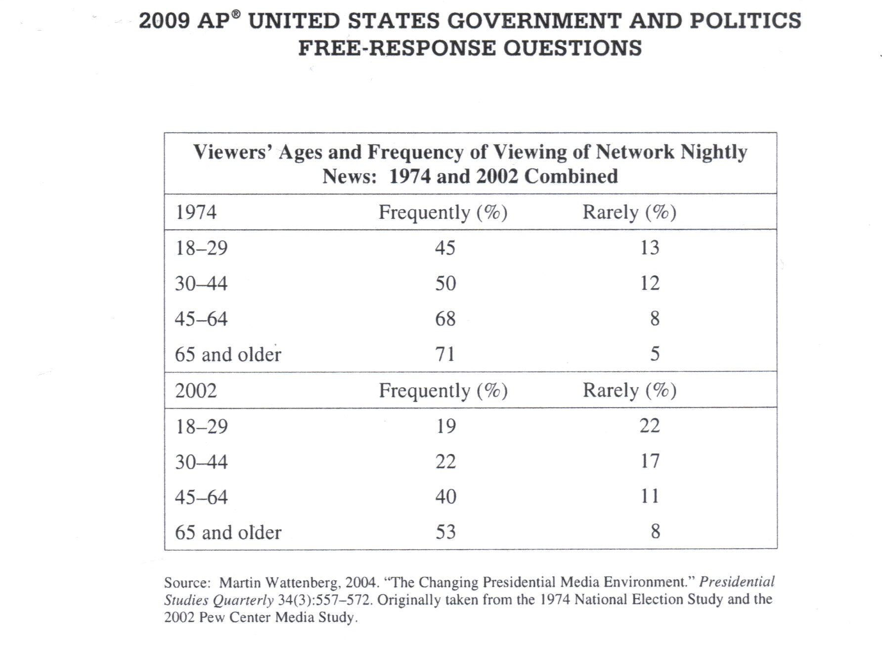

- One of the most important ways the news media influence politics is through agenda setting.
a) define policy agenda
b) explain how the national news media engage in agenda setting.
c) explain the primary reason the president tends to have an advantage over Congress in gaining media attention.
d) Consider the table above.
- Describe the difference in the viewing patterns of older and younger age-groups.
- Describe the change from 1974 to 2002 in viewing habits that exists for all age categories.
e) Given the information in the table, describe one implication for presidents in their use of the media to promote their political and policy objectives to the American public.

Principles Drawn from Released MC’s and FRQ’s (Mass Media)

- The news media’s most important influence on public opinion is that it affects which issues the public thinks are important.
- The largest amount of political coverage in newspapers during Presidential campaigns is devoted to day-to-day activities.
- A policy agenda is a set of issues, problems, or subjects that gets the attention of/is viewed as important by people involved in policymaking (e.g., government officials, government decision-makers)
- The news media engages in agenda setting by: raise awareness, provide information, draw attention, demonstrate the important or consequences of the problem, get the public’s attention, or getting the attention of government/policymakers.
- The president has an advantage over members of Congress in gaining media attention because the president speaks with a single voice, while Congress has many voices, the president represents the nation, members of Congress represent states/districts, the president is the national leader/leader of the country, the president is more powerful than any single member of Congress, the president has constitutional powers that Congress does not have.
- Young people view less TV news than older people/Older people view more TV news than younger people.
- People in all categories viewed less TV news in 2002 than they did in 1974.
Political Parties
  - Minor parties (third parties) have been a common feature of United States politics.
a. Describe the point of view expressed about minor parties in the political cartoon above.
b. Identify and explain how two rules of the United States electoral system act as obstacles to minor-party candidates winning elections.
c. Minor parties make important contributions to the United States political system in spite of the institutional obstacles to their candidates’ success. Describe two of these contributions.

  - While interest groups and political parties each play a significant role in the United States political system, they differ in their fundamental goals.
a. Identify the fundamental goal of interest groups in the political process.
b. Identify the fundamental goal of major political parties in the political process.
c. Describe two different ways by which interest groups support the fundamental goal of political parties in the political process.
d. For one of the forms of support you described in (c), explain two different ways in which that form of support helps interest groups to achieve their fundamental goal in the political process.
Principles Drawn from Released MC’s and FRQ’s (Political Parties)

- Goals of political parties: Elect people to office, gain control of government.
- Know which groups tend to vote for which parties:
  - For example: Each of the following was a part of the New Deal electoral coalition: Blue-collar workers, racial minorities, Southerners, and Farm laborers
- The winner-take-all electoral system makes it difficult for third parties to emerge and survive.
- The decline of Democratic Party strength among White southerners was evident in presidential elections in the 1980’s.
- In the 1992 election, the membership of Congress was altered significantly by an increase in the number of minorities and women.
- Critical elections in the United States typically have occurred when groups of voters have changed their traditional patterns of party loyalties.
- The percentage of voters identifying themselves as either Democrats or Republicans has been declining since the 1970’s.
- Political parties have declined in importance in recent years and interest groups have risen in importance very quickly. This is because interest groups are better able to articulate specific policy positions than political parties.
- The following act as major obstacles to third parties: Winner-take-all aspect of electoral college, ballot access, campaign financing (rules/limits, not effects), federal funding of presidential elections, exclusion from presidential debates, single-member plurality districts
- Contributions of third parties include: New or different ideas or issues, voice for fringe, safety valve or discontent, enhanced participation, room for critical voices, pushes major parties to include otherwise underrepresented concerns/groups, clarify major-party candidates’ positions.
Elections and Campaigns
- Over the last half of the twentieth century, voter turnout in federal elections has declined. During the same period, voter turnout has been higher in presidential elections than in midterm elections.
a) Identify two factors that have contributed to the overall decline in turnout in federal elections and explain how each factor has contributed to the overall decline.
b) identify and explain two reasons why voter turnout has been higher in presidential elections than in midterm elections.

- Trust and confidence in government have declined in recent decades.
a) Explain how divided government has contributed to the decline in trust and confidence in government. Be sure to include a definition of divided government in your response.
b) Explain how the increased cost of election campaigns has contributed to the decline in trust and confidence in government.
c) Explain two specific consequences of the decline in trust and confidence in government for individual political behavior.

- The United States Congress has debated a variety of campaign finance reforms over the last decade. The proposals debated have included the following:
Eliminating soft money
Limiting independent expenditures
Raising limits on individual contributions

a) Select on of the listed proposals and do all of the following:
- Define the proposal.
- Describe an argument that proponents make in favor of the proposal.
- Describe an argument that opponents make against the proposal.
b) Select a different listed proposal and do all of the following:
- Define the proposal
- Describe an argument that proponents make in favor of the proposal
- Describe an argument that opponents make against the proposal.

- Have changes in the formal presidential nomination procedures since the mid-1960’s made the process more democratic? In your response, support your argument by describing three specific changes in the procedures and discussing their effects.

- Since the 1960’s, the process of selecting presidential candidates has been altered by the changing role of presidential primaries and national party conventions. Discuss FOUR effects that have resulted from this change in the presidential selection process.

- The concept of iron triangles, also referred to as sub governments, is used to explain how various interests influence public policy. Applying this concept to agriculture, briefly identify the key players in the iron triangle, analyze how they interact to achieve policy goals, and evaluate the impact of this iron triangle on the democratic process.

- In the 1990’s, presidential election campaigns have become more candidate centered and less focused on issues and party labels. This change has been attributed both to how the media cover presidential campaigns and to how candidates use the media. Identify and explain two ways in which the media have contributed to candidate-centered presidential campaigns. Identify and explain two ways in which presidential candidates’ use of the media has contributed to candidate-centered campaigns.

- Three obstacles have made it difficult for Congress to enact Campaign Finance reform
Buckley v. Valeo
Incumbency
Soft money

Select two of the obstacles. For each obstacle, provide each of the following:
a) a brief description of the obstacle.
b) an explanation of how the obstacle has made it difficult to enact significant Campaign finance reform.

Principles Drawn from Released MC’s and FRQ’s (Elections and Campaigns)

- Campaign finance reforms have attempted to minimize the role of money in influencing the outcome of an election, as was often the case in the past.
- The use of direct primaries instead of the convention system to select presidential candidates has resulted in: a weakening of party control over nominations and an increase in the number of people involved in the choice of candidates.
- Reforms to the presidential nomination process have resulted in the number of female delegates and minority-group delegates at Democratic national conventions growing substantially.
- *The boundary lines of congressional districts are drawn by state legislatures.*
- Voters in presidential primary elections are more likely to be affluent compared to voters in a general election.
- A primary election in which voters are required to identify a party preference before the election and are not allowed to split their ticket is called a closed primary.
- A significant trend in the presidential nominating process over the past three decades is the increasing importance of presidential primaries rather than state conventions.
- Public monies are only used to help finance Presidential campaigns (not congressional or gubernatorial)
- An election involving more than two candidates in which the person who receives the most votes is the winner is called a plurality election.
- The increased cost of election campaigns has contributed to the decline in trust and confidence in government because: Candidates must spend more time raising money, Role of interest groups (PAC’s), corporations and connections to wealthy donors, Keeps good people from running for office, Small contributions don’t matter, Perception that there is wasteful spending.
- The United States Congress has debated a variety of campaign finance reforms over the last decade. The proposals debated have included the following: Eliminating soft money, Limiting independent expenditures, and Raising limits on individual contributions. Arguments have been made in favor and against reforming each:
Eliminating soft money
- Definition: prohibiting or regulating campaign contributions to political parties and/or contributions for party building activities

Acceptable arguments in favor include:
- Soft money is often used to circumvent limits on hard money
- Levels the playing field.
- Lessens concern about the undue influence of “fat cats”/buying of influence.
- Provides more disclosure and transparency.
- Decreases overall costs of campaigns

Acceptable arguments against include:
- First Amendment
- Contrary to ruling in Buckley v. Valeo
- Party money is one step removed between contributor and decision-maker.
- Weakens political parties.
- Might lessen grassroots participation.

Limiting Independent expenditures
- Definition: Limiting money spent by individuals and groups not directly affiliated with the candidate or the party

Acceptable arguments in favor include:
- Can be used to circumvent limits on hard money.
- Levels the playing field.
- Possibly reduces negative issue ads.
- Candidates want to control their own campaigns.
- lessens concern about undue influence of “fat cats”/buying of influence.

Acceptable arguments against include:
- First Amendment
- Contrary to ruling in Buckley v. Valeo.
- Might lessen grassroots participation

Raising limits on individual contributions
- Definition: Increasing the dollar amount individuals may give to a campaign, parties, or PAC’s

Acceptable arguments in favor include:
- Limits are not indexed to inflation.
- Candidates can spend less time fundraising
- Decreased the influence of PAC’s
- Decreased restrictions on First Amendment rights.
- Decreased reliance on less-regulated forms of campaign funds.

Acceptable arguments against include:
- Allows the rich to have/buy more influence
- Too much money in the process already.
- Drives up the cost of campaigns.

Interest Groups
- While interest groups and political parties each play a significant role in the United States political system, they differ in their fundamental goals.
a. Identify the fundamental goal of interest groups in the political process.
b. Identify the fundamental goal of major political parties in the political process.
c. Describe two different ways by which interest groups support the fundamental goal of political parties in the political process.
d. For one of the forms of support you described in (c), explain two different ways in which that form of support helps interest groups to achieve their fundamental goal in the political process.

- Different interest groups will choose different techniques to achieve their objectives based on their resources, characteristics, and goals.
a. Describe each of the following techniques and explain why an interest group would choose each technique.
- Litigation
- Campaign Contributions
- Grassroots lobbying/mass mobilization
b. Select one of the following groups and identify the primary technique it uses from the list in part (a). Explain why the group you selected would employ that technique over the other two techniques.
- American Medical Association (AMA)
- Sierra Club
- National Rifle Association (NRA)
- National Association for the Advancement of Colored People (NAACP).

Principles Drawn from Released MC’s and FRQ’s (Interest Groups)

- Interest groups and political parties promote U.S. democracy by linking citizens to the political process.
- Fundamental goals of interest groups include: Influence public policy, Influence Congress/government, Change laws
- Interest groups support their goals by: Access/influence policymakers, Have like-minded people/policy advocated in office, and Legislation that helps interest groups
- The actions that support these goals: Monetary contributions/political action committee (PAC) donations, Organization/mobilization of people, Media campaigns, Information, Independent committees/527s, Independent expenditures, Endorsement/recruitment of candidates
- Unions engaging in strikes is recognized by law.
- The following groups are examples of those who maintain a national lobbying organization in Washington D.C: Environmentalists, nurses, automobile manufacturers, automobile assembly-line workers
- Interest groups influence the political process by: lobbying, contributing money to candidates, filing lawsuits, appealing to public opinion.
- Interest groups are better able to articulate specific policy positions than are political parties.
- Corporate lobbyists influence Congress by: ensuring corporation’s PAC’s make donations to the campaigns of members in key committees, meet informally with aids over lunch or cocktails, bring influential constituents to Washington to discuss important policy matters with their representatives. They do NOT have any influence over the Judicial Branch.
- The primary function of PAC’s is to raise campaign funds to support favored candidates.
- PAC spending makes up a higher percentage of congressional campaign funds than of presidential campaign funds.
- The amount of money that PAC’s can contribute directly to a candidate is limited by law.
- In The Federalist Papers, Madison expressed the view that factions are undesirable but inevitable in a free society.
- The following are the major ways that interest groups influence policy:
- Litigation- lack broad popular support (numbers or pub opinion) and /or lack influence over legislation/policy, rights issues involved, success establishes firm precedent
- Campaign contributions- financial resources, groups that need access, narrow or focused issue, buy candidate loyalty/support. Groups can recruit/endorse candidates that will support their positions to run for public office, provide testimony, and get members to work for candidates; some form PACs
- Grassroots lobbying (not lobbying in general)/Mass mobilization- popular support but lack of funds, popular support is strength, requires less other resources ($, access), democratic concerns (philosophical approach).
- Lobbying- are a source of information, help politicians plan political strategies for legislation, help politicians plan political strategies for reelection campaigns, are a source of ideas and innovations.

Institutions of National Government (Congress, Presidency, and Bureaucracy)
Congress
(435 representatives and 100 senators)….House v. Senate (study chart on page 375 “…Key Differences”)
  - Party Leadership. Know: Speaker of House, President Pro Tempore, Majority and Minority Leaders, Whips, caucus
  - Powers Unique to the Senate

    - Treaty ratification
    - Confirmation of judicial and executive appointments.
    - Try impeachment/conviction/removal from office
    - These powers are unique because:
    - More mature body
    - More insulated from public opinion/ indirectly elected (originally)
    - Longer and/or staggered terms.
    - Reflects state interests.

  - Powers Unique to the House
    - Initiate revenue bills.
    - Choose the President when the Electoral College is deadlocked.
    - Impeachment.
    - These powers of unique because:
    - Closer to the people.
    - More representative of and responsive to the public/direct election to two-year terms.

  - Additional Powers
    - Congress is empowered to create new federal courts and specify the number of judges who will sit on them.
    - One of the formal tools used by Congress for oversight of the bureaucracy is authorization of spending.
    - The congressional power that has been contested most frequently in the federal courts is the power to regulate interstate commerce (think: Gibbons vs. Ogden)
    - A legislative veto is unconstitutional because they violate the principle of separation of powers.
- Differences in House and Senate (procedures)
House | Senate | Reason(s) [Examples Below]
435 members; 2 yr terms | 100 members; 6 yr terms | - House closer to the people with representation based on population and 2 yr terms  - Senate smaller, more deliberative
Low turnover | Moderate turnover | - Incumbents win re-election over 90% of the time in the House  - Senate races are state-wide and more competitive
Speaker bill referral hard to challenge | Referral decisions easily challenged | - Difficult for individual members to challenge the Speaker of the House; members limited by strict rules  - Members of the Senate more independent operators
Scheduling/rules controlled by majority party; powerful Rules  Committee | Scheduling/rules agreed to by majority & minority leaders | - House - majority party tightly controls Leadership and Rules with little minority party. Rules committee plays “traffic cop” role.  - Senate – much more cooperation between parties
Debate limited to 1 hour | Unlimited debate unless cloture invoked | - Impractical with 435 members to have unlimited debate in the House; nothing would get done  - Senate has only 100 members; more time
Members policy specialists | Members policy generalists | - House – in order to get re-elected, members most become experts in policies that directly effect their districts; must serve on those committees  - Senators represent diverse interest of an entire state
Emphasizes tax & revenue policy | Emphasizes foreign policy | - All tax and revenue bills must originate in the House; much of public policy decisions in HR involve the budget  - Senate “advice and consent” of ambassadors, cabinet; ratify treaties
More formal & impersonal | More informal & personal | - House much bigger, need strict rules to be efficient; members 1 of 435  - Senate smaller, more collegial; members 1 of only 100
Committee System important | Committee system less important | - House is larger so more work can be accomplished through committees on floor.  - Senate smaller so committees not as necessary to complete work.
May not “hold” a bill | May “hold” a bill | - House may pass a bill with an individual member’s objections.  - An individual Senator can allow a Senator to temporarily stop a motion from reaching the floor.
No unanimous consent | Unanimous consent agreements allowed | - The Senate can ease passage of a bill with unanimous consent agreements. Thus, if no one objects to a motion, it is passed.  - The House has no such mechanism
May not use germaneness | May use germaneness | - Senate can add unrelated content that members of the House might find objectionable. Germaneness is the right to challenge the ruling of a presiding officer during debate.

  - Incumbency is the most important factor that determines which candidate will win an election. (win more than 90% of time). This provides expertise and stability to Congress but also insulates it from change.
    - Incumbents in the House are more likely to be reelected, however, because Senators are more high profile and are more likely to be held accountable for public policy.
    - Advantages of incumbents:
      - Advertising/name recognition
      - Credit claiming: can work for constituents pork barrel or casework.
      - Position Taking: public image strengthened because already taken a stand on issues relevant to their constituents.
      - Party Identification: voters vote on party lines, thus how a district tends to lean will affect whether or not an incumbent wins.
      - Campaign spending: often due to contributions from interest groups and PAC’s
  - Franking privilege is extended to all members of Congress. It means members of Congress can send mail to their constituents at the government’s expense.
- Congressional boundaries are drawn by state legislatures (know: gerrymandering, malapportionment, reapportionment, redistricting)
  - “critical elections” are most likely associated with party realignment.
- Committees
  - House Rules Committee sets conditions for debate and amendment of most legislation. Also puts bills on calendar for debate.
  - Appropriations Committees (both houses)- decides how government money will be apportioned to federal agencies.
  - House Ways and Means Committee- writes bills concerning tax and other public revenue.
  - Senate Finance Committee-works with House Ways and Means Committee to write tax revenue bills.
  - Types:
    - Standing: handles specific policy area. Both House and Senate have them. Often divided into subcommittees. (list on page 379)
    - Joint Committees: oversee areas where policy overlaps. Made up of representatives and Senators.
    - Select Committee: handles specific issues, like an investigation or impeachment trial.
    - Conference Committee: iron out differences between the House and Senate version of a bill. Have members of both Houses.
  - Committee chairs influence agenda of most committees. Chair is a member of majority party and is the most senior member of majority party of committee. Minority party member with longest tenure called ranking member. The Seniority system was a formal rules used to select hairs, but is no longer a requirement.
- How A Bill Becomes Law

Possible FRQ’s for Congress
- Both party leadership and committees in Congress play key roles in the legislative process.
a. Define two of the following elements of the congressional committee systems and explain how each influences the legislative process.
- Specialization
- Reciprocity/logrolling
- Party representation on committees
b. Identify two ways party leadership in Congress can influence the legislative process, and explain how each way influences the process
- The framers of the United States Constitution created a legislative system that is bicameral. However, it is not just bicameral; the framers also established two houses of distinctly different character and authority.
a. Discuss two reasons why the framers created a bicameral legislature
b. Identify one power unique to the House of Representatives and explain why the framers gave the House that power.
c. Identify one power unique to the Senate and explain why the framers gave the Senate that power.
- Congressional reapportionment and redistricting are conducted every ten years. When redistricting is conducted, politicians often engage in gerrymandering.
a. Define congressional reapportionment and explain one reason why it is important to states.
b. Define congressional redistricting.
c. Explain two goals of politicians when they gerrymander during redistricting.
d. Describe two limits that the US Supreme Court has placed on congressional redistricting.
- In the United States Congress, the majority party exerts a substantial influence over lawmaking. However, even when one party has a numerical majority in each chamber of the United States Congress, there is no guarantee that legislation supported by that majority party will be passed by both chambers. Rules of each chamber independently influence the likelihood that legislation will pass in that chamber; legislation passed by one chamber is not always passed by another.
a. Describe two advantages the majority party in the United States House of Representatives has in lawmaking, above and beyond the numerical advantage that the majority party enjoys in floor voting.
b. Describe two differences between House and Senate rules that may make it likely that legislation may pass in one chamber but not in the other.
c). Explain how the differences identified in (b) can lead to the passage of a bill in one chamber but not in the other.

Principles Drawn from Released MC’s and FRQ’s (Congress)
Representatives and Senators
- Members of Congress are directly elected by registered voters.
- The most important variable in determining the outcome of an election for a member of the House has been incumbency.*
- Incumbents have an advantage over challengers because they can use staff members to do services for their constituents (individual voters)**, they are better known to voters, they find it much easier to raise campaign funds than challengers, and they often serve on committees that enable them to help their constituency.
- Elections in the House of Representatives provide approximately equal representation for every voter.
- Communication between congressional representatives and constituents occurs mainly through the personal staffs of representatives.*
- Members of Congress DO NOT receive government funds for their campaigns (only Presidents).
House vs. Senate (comparison and contrast)
The framers created a bicameral majority because:
  - Compromise at Constitutional Convention (representation of large vs. small population states)
  - Compromise among competing interests/protect minority inter5est
  - Slow the process
  - Different types of representation/federalism
  - An intrabranch check/prevent majority tyranny.
- Incumbent senators are less likely to be reelected than are incumbent members of the House of Representatives.*
- The following are differences between the legislative process in the House of Representatives and in the Senate:
  - Debate is more restricted on the House floor than on the Senate
  - The amendment process is more restricted in the House than in the Senate
  - A *Rules Committee sets the guidelines for floor debate in the House but not in the Senate.
(essentially, the House operates by more formal rules than the Senate, who operates more in informal understandings.)
- The committee system is more important in the House than in the Senate because the House is so large that more work can be accomplished in committees than on the floor.
- A few of the advantages the majority party has in the House include: Holds committee chairs, Controls Rules Committee, Sets the agenda, Controls debate, Chooses the Speaker of the House, Holds majority on each committee, and Assigns bills to committees
- Some basic differences between the House and Senate include: (need to make a big, detailed chart for students to fill out using book in class…maybe do this after the full discussion of the Congress as a review/reinforcement activity)

 | House | Senate
Procedures and Rules | More Formal | Less Formal
Filibuster | No | Yes
Holds | No | Yes
Unanimous consent agreements | No | Yes
Germaneness requirement | Yes | No
Rules Committee | Yes | No
The differences between the House and the Senate affect passage of a bill through the following factors:
- Filibuster- even though the House may pass a bill, the Senate can kill the bill with a filibuster.
- Holds- even though the House may pass a bill, the Senate, can delay or stop it with a hold.
- Unanimous consent agreements- The Senate can ease passage of a bill with unanimous consent agreements, while the House has no such mechanism
- Germaneness- The Senate can add unrelated content that members of the House might find objectionable.
- Rules Committee- even though the Senate may pass a bill, the House Rules Committee can hinder passage of that bill in the House.

Powers unique to the House of Representatives:
- Initiate revenue bills.
- Choose the President when the electoral college is deadlocked.
- Impeachment
These powers of unique because:
- Closer to the people.
- More representative of an responsive to the public/direct election to two-year terms.

Powers unique to the Senate include:
- Treaty ratification
- Confirmation of judicial and executive appointments.
- Try impeachment/conviction/removal from office.
These powers are unique because:
- More mature/”august” body
- More insulated from public opinion/indirectly elected (originally)
- Longer and/or staggered terms.
- Reflects state interests.

Organization of Congress (parties, caucuses, committees, staff, etc.) MANY QUESTIONS ABOUT COMMITTEES
- Be familiar with the major types of committees and their purpose (example: judiciary, agriculture, rules, foreign affairs, and science and technology)
- The power of the *Rules committee in the House of Representatives rests on its authority to place a bill on a legislative calendar, limit time for debate, and determine the type of amendments allowed.
- The role of conference committees is to reconcile differences in bills passed by the House and Senate.
- The details of legislation are usually worked out in subcommittees.
- Most of the bills introduced in the House and the Senate are then referred to committee but never sent to the full Congress.
- The influence of committee chairs has decreased in Congress over the past twenty years.
- The congressional system of standing committees is significant because it fosters the development of expertise by members. They are best described as permanent subject-matter committees. *
- Standing committees tend to oversee the bureaucracy’s implementation of legislation.
Congress in Action (Powers of Congress)
- Debate of a bill in the House of Representatives under a “closed rule” means that amendments to the bill may not be offered.
- “Pork Barrel” legislation helps the reelection chances of a member of Congress because such legislation helps earn a member of Congress a reputation for service to his or her district.
- A “cloture notion” passed in the Senate cuts off debate on a bill.
- Congress is empowered to create new federal courts and specify the number of judges who will sit on them.
- The legislative process is frequently lengthy, decentralized, and characterized by compromise and bargaining.
- One of the formal tools used by Congress for oversight of the bureaucracy is authorization of spending.
- The congressional power that has been contested most frequently in the federal courts is the power to regulate interstate commerce (think: Gibbons vs. Ogden)
- Congressional reapportionment is: The reallocation of the number of representatives each state has in the House of Representatives.
- Congressional reapportionment is important to states because:
- Reapportionment increases or decreases the number of seats a state has in the House/Congress (not the Senate).
- More representatives mean that a state has more influence.
- Reapportionment increases or decreases a state’s number of electoral votes.
- The drawing/redrawing of House/congressional (not Senate) district lines
- The primary goal of politicians when they gerrymander is:
  - To enhance political party strength/to minimize the strength of the opposition party.
  - To protect incumbents/to discourage challengers.
  - To increase minority representation/to decrease minority representation.
  - To punish foes/to reward friends
Presidency
Terms: line-item veto, 25th Amendment, impeachment, presidential coattails, pocket veto
- Roles of President (*= Constitutional)

      - Chief of State*
      - Chief Executive*
      - Chief Administrator*
      - Chief Diplomat (negotiate treaties)*
      - Commander in Chief.*
      - Chief Legislator (present State of Union)*
      - Chief of Party
      - Chief Citizen
      - Crisis Manager
      - Moral Persuader

- Be familiar with Presidential Powers…distinguish between formal and informal powers.
- Informal Presidential Powers include: Executive Orders (used more frequently since 1970’s because do not need to be passed/approved by Congress), Executive Privilege, and Executive Agreements
- The Public President
  - Presidents try to transform popularity into congressional support for their programs
  - The public may not be receptive to the president’s message or misperceive it all together.
  - Presidential coattails have had a declining effect for years
  - A President’s popularity tends to fall during his term in office.
- Running the Government
  - Cabinet: advisors to the President regarding a specific policy area. Not a constitutional office, but every President has had one. (1 Attorney General, 14 Secretaries).
  - Executive Office Of President: administrator and advisory bodies that assist President in overseeing policy. Consists of National Security Council, Council of Economic Advisors, Office of Management and Budget, and White House Office (Personal and political advisors to the President. Takes care of political needs and manages the press. Principal staff for President has been made up of members of this office)
    - Cabinet appointments require Senate confirmation as well as some key independent executive agencies (Secretary of State, Director of the FBI, and Attorney General, for example). The White House Staff and the Executive Office of the President do NOT require Senate approval. (Chief of Staff, for example).
- War Powers Resolutions
  - It was designed to assure congressional involvement in decisions committing military forces in hostile situations overseas.
  - Provisions
    - The President must notify Congress within 48 hours of sending troops into combat.
    - President must consult with Congress whenever feasible
    - Conflicts are limited to 60 days unless Congress takes action
    - Congress can extend time from the initial 60 days or can withdraw troops after 60 days with adequate notification to the President.
Bureaucracy
- Classic conception of bureaucracy (Max Weber)—a hierarchical authority structure that use task specialization, operates on the merit principle, and behaves with impersonality
- Civil Service System relies on entrance exams and civil servants promoted by merit rather than patronage. (Pendleton Civil Service Act).
  - Department of Defense has largest number of civil employees, followed by U.S. Post Office.
  - Cabinet Departments oversee and administer various policy areas. Regulatory agencies oversee a particular aspect of the economy, create regulations that protect people. Government corporations perform services for a fee, like a private business. (examples: Post Office, Amtrak, and Tennessee Valley Authority). Independent Executive Agencies include all other executive bodies. Most created for a specific purpose like NASA.
- Bureaucracies are in charge of policy implementation. Implementation can be difficult if the program design is flawed. Congress may not be clear enough about policy goals, may provide a lack of resources, the standard operating procedures may be inflexible, and confusion may result from several departments being involved in the implementation of a particular policy. (Voting Rights Act of 1965 an example of successful implementation)
- The President has difficulty controlling cabinet-level agencies for the following reasons:
  - Agencies often has political support from interest groups
  - Agency staff often have information and technical expertise that the President and his/her advisers lack
  - Civil servants who remain in the administration through changes of administration develop loyalty to their agencies
  - Congress is a competitor for influence over the bureaucracy.
Possible FRQ’s for Executive Branch
- The concept of “divided government in the United States means that one political party can control the executive branch while another controls the legislative branch. This poses problems for the President in making appointments to federal offices.
- Describe two problems that divided government poses for the President in making federal appointments.
- Identify and explain two ways Presidents try to overcome the problems described in (a).

- Presidential approval ratings fluctuate over the course of each presidential administration.
- Identify two factors that decrease presidential approval ratings, and explain why each factor has that effect.
- Identify two factors that increase presidential approval ratings, and explain why each factor has that effect.

- Presidents are generally thought to have advantages over Congress in conducting foreign policy because of the formal and informal powers of the presidency.
- Identify two formal constitutional powers of the President in making foreign policy.
- Indentify two formal constitutional powers of Congress in making foreign policy.
- Identify two informal powers of the President that contribute to the President’s advantage over Congress in conducting foreign policy.
- Explain how each of the informal powers identified in (c) contributes to the President’s advantage over Congress in conducting foreign policy.

- Conflicts between Congress and the President over war powers have their origin in the United States Constitution. In 1973 Congress passed the War Powers Resolution in an attempt to clarify the balance of powers between the two branches of government.
- Describe the primary constitutional conflict between Congress and the President over the decision to go to war.
- Describe two provisions of the War Powers Resolution that were designed to limit the President’s power over war making.
- The War Powers Resolutions has received mixed reviews, but Congress has other powers over war making. Other than the Constitutional power that you described in a, identify and explain two other formal powers Congress has over war making.

- A number of factors enable presidents to exert influence over Congress in the area of domestic policy; however, presidents are also limited in their influence over domestic policy making Congress.
(a) The Constitution grants the president certain enumerated powers. Describe two of these formal powers that enable the president to exert influence over domestic policy.
(b) Choose two of the following. Define each term and explain how each limits the president’s ability to influence domestic policymaking in Congress.
- Mandatory spending
- Party polarization
- Lame-duck period

- The United States Congress and the President together have the power to enact federal law. Federal bureaucratic agencies have the responsibility to execute federal law. However, in the carrying out of these laws, federal agencies have policy-making discretion.
- Explain two reasons why Congress gives federal agencies policy-making discretion in executing federal laws.
- Choose one of the bureaucratic agencies listed below. Identify the policy area over which it exercises policy-making discretion AND give one specific example of how it exercises that discretion.
  - Environmental Protection Agency (EPA)
  - Federal Communications Commission (FCC)
  - Federal Reserve Board
- Describe two ways in which Congress ensures that federal agencies follow legislative intent.

Principles Drawn from Released MC’s and FRQ’s (Congress)
Presidency
- Directly electing a Presidential candidate would result in each vote counting equally.
- Since 1960, the Presidential Election process has been affected by an increase in all of the following: proportion of independents in the electorate, influence of political consultants, number of primaries, role television.
- Veto Power: Presidents sometimes veto: A President sometimes threatens to veto a bill that is under discussion in order to influence congressional decision-making; Congress is usually able to override a President’s veto.
- Those who would support a line-item veto argue that this power would increase the President’s ability to control federal spending. A president requesting this power is a challenge to the principle of separation of powers.
- When selecting a vice-presidential candidate, a presidential nominee is usually concerned primarily with choosing a running mate who adds balance and appeal to the national ticket.
- The following procedures result in impeachment: The House votes for impeachment and the Senate conducts a trial and reaches a guilty verdict.
- The following have resulted in an increase in presidential power in the post-1945 era: tensions between the United States and the Soviet Union during the Cold War period, an increase in public expectations for services from the federal government, economic and domestic problems such as inflation, unemployment, and civil rights issues, increasing United States involvement in international affairs.

Acceptable identifications of explicit, formal constitutional powers of the President in foreign policy may include:
- Commander-in-chief, power to commit troops
- Appointment of ambassadors and foreign policy officials
- Negotiate/make treaties
- Recognition of nations
- Receive ambassadors and other public ministers.

Acceptable identifications of informal powers of the President may include:
- Executive Agreements
- Access to media/bully pulpit/morale building
- Agenda setting
- Meet with world leaders
- Crisis manager
- International coalition building
- President has access to more information, knowledge, or expertise than does Congress
- Recognized as global leader

- Powers of President over domestic policy:
  - Legislative powers (veto, pocket veto, signing legislation)
  - State of the Union address
  - Appointment power(to a domestic office)
  - Calling Congress into session
  - Commander-in-chief role
President and Congress
- A president may persuade recalcitrant members of Congress to vote for a particular bill by making a direct appeal to the public through the mass media.* He also can assign legislative liaisons in the Executive Office of the President to lobby legislators, exploiting a partisan majority for the President’s party in both the House and Senate, and reminding legislators of high popularity ratings for the President in public opinion polls.
- Invocation of the War Powers Act of 1973 would be most important in determining the nature of the commitment of the United States military to a peace-keeping role in the world. It was designed to assure congressional involvement in decisions committing military forces in hostile situations overseas. It specified that the President must bring troops home from hostilities within 60 to 90 days unless Congress extends the time.**
- Provisions of War Powers Act:
  - The President must notify Congress within 48 hours of sending troops into combat.
  - President must consult with Congress whenever feasible
  - Conflicts are limited to 60 days unless Congress takes action
  - Congress can extend time from the initial 60 days or can withdraw troops after 60 days with adequate notification to the President.
- Powers of Congress in War Making:
  - Passing laws
  - Appropriations (any mention of “funding”)
  - Confirmation of nominees
  - Impeachment
  - Treaty ratification
  - Congressional oversight (hearings or investigations).
- In trying to influence legislation, the President is usually more successful than congressional leaders in using the media to set the policy agenda. .
- The President has advantages over Congress in the area of foreign policy because
  - Acceptable explanations of the President’s advantage over Congress may include:
  - Persuade Congress: negotiate, offer support, threats, etc.
  - Persuade public: (various means of persuasion) on foreign policy process/issues (e.g, apply pressure to Congress)
  - Ability to circumvent the formal process

- Informal Powers of Congress in foreign policy
  - Confirm ambassadors
  - Power of the purse in military/foreign policy matters
  - Declare war
  - Pass laws/resolutions regarding foreign policy issues
  - Regulate foreign commerce (including trade agreements)
  - Ratify treaties
Bureaucracy
- The President has difficulty controlling cabinet-level agencies for the following reasons: Agencies often has political support from interest groups, agency staff often have information and technical expertise that the President and his/her advisers lack, civil servants who remain in the administration through changes of administration develop loyalty to their agencies, Congress is a competitor for influence over the bureaucracy.
- An advantage that bureaucrats in federal government have over the President in the policymaking process is that bureaucrats usually have a continuity of service in the executive branch that the President lacks.
- The usefulness to the President of having cabinet members as political advisers is undermined by the fact that the loyalties of cabinet members are often divided between loyalty to the President and loyalty to their own executive departments.
- One of the formal tools used by Congress for oversight of the bureaucracy is authorization of spending.
- Reasons why Congress gives federal agencies policy-making discretion in executing federal laws include:
- Congress lacks expertise/agencies have expertise.
- Congress does not want to be blamed for bad policy.
- Time-consuming
- Easier to come to agreement
- More efficient

- Ways in which Congress ensures that federal agencies follow legislative intent include:

  - Oversight
  - Budget/appropriations
  - Hearings
  - Investigations
  - Government Accountability Office (GAO)
  - Change law.
  - Legislative veto
  - Casework

  - Sunset laws/reauthorization/dissolve agencies/create new agencies

* Question seen on two released tests
** Question seen on three released tests
Public Policy
- Entitlement spending is the largest portion of “uncontrollable spending” in the federal budget (because nondiscretionary)
  - Federal benefits that must be funded by Congress and must be paid to all citizens who meet eligibility criteria are called “individual entitlements.”

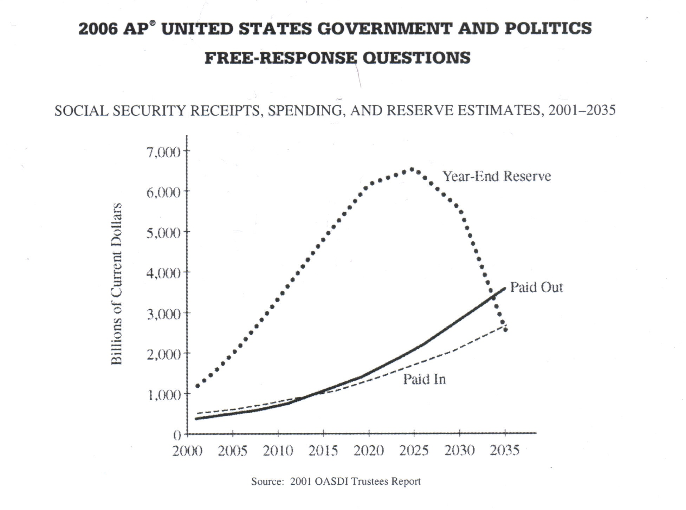
Possible FRQ’s for Public Policy

- In recent decades, entitlement programs have constituted a substantial portion of the United States federal budget, Social Security is the largest entitlement program in the United States. From the information in the chart above and your knowledge of United States government and politics, perform the following tasks.
- define entitlement program
- What is the primary source of revenue for the Social Security program?
- Identify one threat to the future of the Social Security program should the trends depicted in the chart above continue.
- Describe one demographic trend that threatens the future of the Social Security program AND explain how it is responsible for the threat that you identified in (c).
- Explain how any one of the trends in the c hart above would change if the age of eligibility for Social Security were raised.
- Fiscal Policy and Monetary policy are two tools used by the federal government to influence the United States economy. The executive and legislative branches share the responsibility of setting fiscal policy. The Federal Reserve Board has the primary role of setting monetary policy.
- Define fiscal policy.
- Describe one significant way the executive branch influences fiscal policy.
- Describe one significant way the legislative branch influences fiscal policy.
- Define monetary policy.
- Explain two reasons why the Federal Reserve Board is given independence in establishing monetary policy.
- A number of factors enable presidents to exert influence over Congress in the area of domestic policy. However, presidents are also limited in their influence over domestic policymaking in Congress.
a) The Constitution grants the president certain enumerated powers. Describe two of these formal powers that enable the president to exert influence over domestic policy.
b) Choose two of the following. Define each term and explain how each limits the president’s ability to influence domestic policymaking in Congress.
- Mandatory spending
- Party polarization
- Lame-duck period

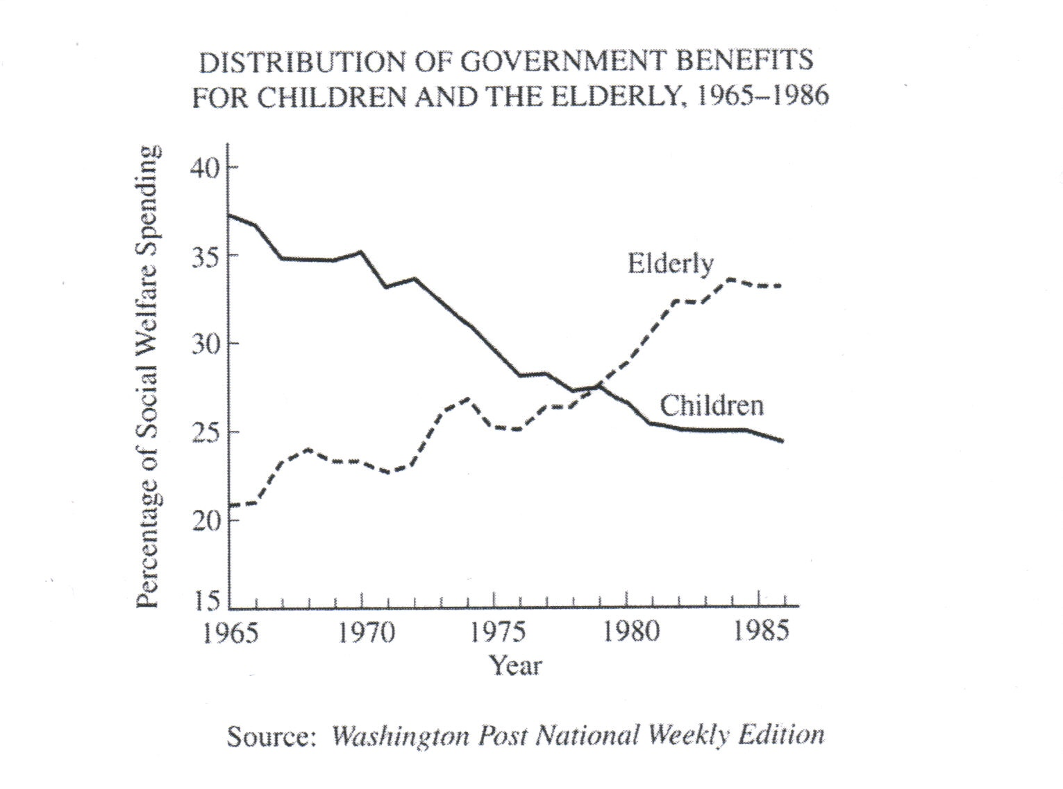

- Using the information in the figure above and your knowledge of United States policies, complete the following tasks.
- Describe what the figure above demonstrates about the distribution of government benefits over time.
- Identify two politically relevant factors that have affected the changing distribution of government benefits between children and the elderly.
- Explain how each of the two factors identified in (b) has affected the changing distribution of government benefits

Principles of Released MC’s and FRQ’s (Public Policy)

- The activities of the Federal Reserve board have the most direct influence on bank interest rates
- The Office of Management and Budget is responsible for the preparation of executive spending proposals submitted to Congress.
- The best predictor of a department’s annual budget (like the department of Education)is the size of the previous year’s budget.
- Independent regulatory commissions are created primarily for the purpose of regulating industries to protect the public’s interest.
- Diversity of public policy throughout the United States is primarily a consequence of federalism.
- Fiscal policy is taxing and/or spending.
- The Executive Branch has control over fiscal policy through: The budget, The president proposes/prepares the federal budget, The president signs/vetoes legislation (related to taxing, spending, and borrowing, not generic), The White House Office of Management and Budget (OMB) recommend the budget.
- The Legislative Branch has control over fiscal policy through: Congress passes the federal budget, Congress acts on tax and spending legislation, The Congressional Budget Office (CBO) advises Congress on Economic policies.
- Monetary policy is: Regulating the money supply, Controlling inflation/deflation, Adjusting interest rates to regulate the economy, Adjusting bank reserve requirements, The cost of money,
- The Federal Reserve is given independence in decision-making because: It removes politics from monetary policy decision making, Congress/the president can abdicate responsibility for difficult decisions by delegating decision-making power, The Federal Reserve Board relies on expertise when making decisions, The Federal Reserve Board makes economic policies efficiently.
- Entitlement programs are government-sponsored programs providing mandated/guaranteed/required benefits to those who meet eligibility requirements/qualifications
- The primary source of revenue for Social Security is: Payroll taxes, Wages from existing wage earners, Tax based on earned income, Targeted/earmarked taxes
- Threats to the future of the Social Security program include: Run out of money, Outputs exceed inputs, Declining reserve.
- Demographic trends affecting Social Security: More older people/”baby boom” generation, People living longer/greater life expectancy, Declining birth rates
- Who is responsible for these threats? The number of workers who fund Social Security is decreasing, but the number of people eligible for Social Security is increasing, The number of working people cannot support the large population who will soon reach the age of eligibility to receive Social Security, The ratio of workers to retirees is becoming more unequal. With fewer workers, less money is being paid in, and with more retirees, more money is being paid out.
- The trends would change if the age of eligibility for Social Security were raised because if people were to work longer, less money would be paid out/more money would be paid in/the reserve would not decline as rapidly or as much.

Judicial Branch, Civil Liberties, and Civil Rights
- Judicial Branch
  - Terms to know:
    - Amicus curiae brief- briefs written by interest groups on behalf of litigants to the SC. jurisdiction (original an d appellate), district courts, circuit courts of appeal, precedent or stare decisis
  - Supreme Court appointments are life-time appointments, which mean the President’s appointments can influence public policy far beyond their terms in office. This is why SC judges are likely to have political experience so the President knows their views on certain issues.
    - Senatorial Courtesy is often used in selecting justices. Senators in the state where the district is located recommend a person to the President, who, usually, concedes. This does NOT happen in Supreme Court nominations.
  - The Supreme Court is unlikely to hear a case on appeal from a lower court. They only hear about 100 out of 8000 appeals per year.
  - Original intent seeks to determine the meaning of the Constitutional according to the intentions of the framers. Many “originalists” believe that the judicial branch has become too powerful and favor judicial restraint. Judicial activists wish to allow justices the freedom to forge new policies, especially concerning people underrepresented in the political process.
  - Checks on Judiciary (ways judges are accountable to the people)
    - Impeachment, Congress can clarify “legislative intent” or pass laws regarding jurisdiction, executive enforcement of judicial interpretations, and amendments to the Constitution.
  - John Marshall: initiated the practice of judicial review in Marbury v. Madison and expanded the power of the Supreme Court significantly
  - The Warren Court became actively involved in expanding civil rights and liberties
  - The Burger Court was more conservative but still upheld allowed abortion in Roe v. Wade.
  - The Rehnquist Court became more conservative and began to limit some of the liberal rulings from the previous two courts.
- Civil Liberties. The legal constitutional protections against the government
  - REVIEW ALL THE SC CASES FROM THE LIST GIVEN OUT IN CLASS. While reviewing, ask self: In what ways were the following incorporated to the states? rights of criminal defendants, First Amendment, privacy rights
  - Define selective incorporation- gradual interpretation, one case at a time, that interpreted the Fourteenth Amendment as extending most of the requirements of the Bill of Rights to the states, as well as the federal government.
  - First Amendment (religion)
    - 5 components: speech, press, religion, assembly, petition
    - 2 parts of freedom of religion: establishment clause (“wall of separation” principle) and free exercise clause (no one may interfere with one’s right to practice religion of choice).
    - Lemon v. Kurtzman (1971): The SC set up a test for allowing federal funding of parochial schools: Secular purpose, Neither enhances nor inhibits religion, No excessive entanglement between government and religion.
  - First Amendment (Speech) Know: prior restraint, symbolic speech
    - The Supreme Court has taken the following positions with regard to freedom of speech:
      - a restriction of freedom of speech will always be viewed with skepticism
      - government has an obligation to try to ensure citizens the right to be heard
      - the right of free speech is a fundamental natural right
      - the first amendment protects free speech from incursions of both the federal and state governments. (due to what doctrine?)
    - Some have argued that the legislature may make “no law” bridging freedom of speech or the press, there has been at least 4 forms of speaking and writing not automatically granted full protection:

      - Libel

      - Obscenity
      - Symbolic speech
      - False advertising

    - Speech is limited if it presents a “clear and present danger.”
    - Permissible to advocate the violent overthrow of government in abstract, but not to incite anyone to imminent lawless action
    - Speech is generally protected in public places, but usually not on another’s private property
    - Obscenity: The SC has made it clear that nudity and sex are not, by definition, obscene, and that they will provide First Amendment protection to anything that has political, literary, or artistic merit, allowing the government to punish only the distribution of “hard-core pornography”
      - Decisions on obscenity are based on local community standards.
  - Fifth Amendment, etc - Due Process of Law (Part III) KNOW: 4th, 5th, 6th, and 8th Amendment, self-incrimination
    - Miranda v. Arizona declared that police must inform criminal suspects of their constitutional rights before questioning suspects after arrest.
  - Fourteenth Amendment Equal Protection under the Law (Part IV)
    - The principle that the government must respect ALL of the legal rights that are owed to a person according to the law.
    - Conceptions of Equality

      - Equal opportunity: same chances
      - Equal results: same rewards
  - Right of Privacy (Part V)
    - Roe v. Wade and Griswold v. Connecticut were based on the right to privacy implied in the Bill of Rights
- Civil Rights- policies that extend basic rights to protect people against arbitrary or discriminatory treatment by government or by other individuals
  - Know: 24th Amendment, 19th Amendment
  - Civil Rights Act of 1964
    - Made racial discrimination illegal in hotels, restaurants, and other public accommodation
    - Forbade employment discrimination based on race
    - Created Equal Employment Opportunity Commission (EEOC)
  - Prevention tactics designed to keep Blacks from voting in South: Literacy tests, Poll taxes, Grandfather clauses, Dilution of voting strength through redistricting, White primaries, Election procedures (notification, access)
  - Tactics of African Americans to achieve equality: Demonstrations/ protests/ public rallies/civil disobedience (sit-ins, “freedom rides”), Organized interest-group activity (e.g., NAACP), “Civil Rights, eventually, became less a matter of gaining entry into the political system and more one of waging interest group politics within that system”, Courts/litigation, Boycotts, Election activities other than voting (campaigning, donating)
  - Voting Rights Act of 1965 was one of the best implemented acts because it had a well-defined mission and contained sufficient support to carry out its provisions. It resulted in a greater participation of voter registration by African American voters in the South.
  - Title IX of the Education Amendments Act of 1972 "No person in the United States shall, on the basis of sex, be excluded from participation in, be denied the benefits of, or be subjected to discrimination under any education program or activity receiving Federal financial assistance..."
  - Most visible in high school and college athletics.

Key Cases to Know:
- Baker v. Carr- “one person one vote”
- Barron v. Baltimore- In this ruling, the Supreme Court ruled that the Bill of Rights did not apply to the states
- Betts v. Brady- Betts was indicted for robbery in Maryland. An indigent, he was unable to afford counsel and requested one be appointed for him. The judge in the case denied the request, and Betts subsequently pled not guilty while maintaining he had a right to counsel and arguing his own defense. The Court ruled that the previously discovered right to counsel provided by the fourteenth amendment does not compel states to provide counsel to any defendant. Justice Owen Roberts' opinion asserted that the right to counsel merely prevented the state from interfering in a defendant’s request for representation rather than requiring a state to offer counsel.
- Brown v. Board of Education- This Supreme Court ruling held that segregated schools violated “separate but equal” and was unconstitutional
- Brown v. Board of Education II- This case laid out how desegregation would take place. “with all deliberate speed.”
- Engel v. Vitale- This ruling declared state sponsored prayer to be unconstitutional (even non-denominational). Firmly committed state to neutrality.
- Everson v. Board of Education- announced “wall of separation” principle. Decision upheld a New Jersey program that established the precedent that a state may provide, with public money, bus transportation services to and from school to students in parochial schools.
- Gideon v. Wainright- This Supreme Court case required that attorneys be provided to citizens as part of their due process rights. Extended right of attorney to ALL felony charges, not just federal crimes. Overturned Betts v. Brady.
- Gitlow v. New York- This was the first Supreme Court case to nationalize part of the Bill of Rights (nationalized the first amendment). Used 14th Amendment to justify.
- Griswold v. Connecticut- This was the first Supreme Court case that established a Constitutional right of privacy, and paved the way for the landmark ruling on abortion. Privacy embedded in Bill of Rights.
- Heart of Atlanta Motel v. US - Title II of the Civil Rights Act of 1964 forbade racial discrimination by places of public accommodation if their operations affected commerce. The Heart of Atlanta Motel in Atlanta, Georgia, refused to accept Black Americans and was charged with violating Title II. The Court held that the Commerce Clause allowed Congress to regulate local incidents of commerce, and that the Civil Right Act of 1964 passed constitutional muster.
- Lemon v. Kurtzman- In this ruling, the Supreme Court Justices created a three prong test to better evaluate separation of church and state issues
- Mapp v. Ohio- Incorporated exclusionary rule, which prevents illegally seized evidence from being used in court. Dolree Mapp was convicted of possessing obscene materials after an admittedly illegal police search of her home for a fugitive. She appealed her conviction on the basis of freedom of expression. The Court brushed aside the First Amendment issue and declared that "all evidence obtained by searches and seizures in violation of the Constitution is, by [the Fourth Amendment], inadmissible in a state court." Mapp had been convicted on the basis of illegally obtained evidence.
- Marbury v. Madison- This decision established the principle of the court’s power of Judicial Review
- McCulloch v. Maryland- This ruling allowed for the expansion of federal power over the states through new interpretation of the “necessary and proper” clause of the Constitution. In a unanimous decision, the Court held that Congress had the power to incorporate the bank and that Maryland could not tax instruments of the national government employed in the execution of constitutional powers. Writing for the Court, Chief Justice Marshall noted that Congress possessed unenumerated powers not explicitly outlined in the Constitution. Marshall also held that while the states retained the power of taxation, "the constitution and the laws made in pursuance thereof are supreme. . .they control the constitution and laws of the respective states, and cannot be controlled by them."
- Miller v. California- Clarified what could be obscene. This case established a three prong test for Justices to use when faced with questions of obscenity. No serious artistic intent, offensive, and adapted to local standards/communities.
- Miranda v. Arizona- This Supreme Court ruling established the requirement that criminal suspects be read their rights at the time of their arrest. Remain silent and right to an attorney.
- Planned Parenthood v. Casey- The Pennsylvania legislature amended its abortion control law in 1988 and 1989. Among the new provisions, the law required informed consent and a 24 hour waiting period prior to the procedure. A minor seeking an abortion required the consent of one parent (the law allows for a judicial bypass procedure). A married woman seeking an abortion had to indicate that she notified her husband of her intention to abort the fetus. These provisions were challenged by several abortion clinics and physicians. A federal appeals court upheld all the provisions except for the husband notification requirement. The Court again reaffirmed Roe, but it upheld most of the Pennsylvania provisions. For the first time, the justices imposed a new standard to determine the validity of laws restricting abortions. The new standard asks whether a state abortion regulation has the purpose or effect of imposing an "undue burden," which is defined as a "substantial obstacle in the path of a woman seeking an abortion before the fetus attains viability." Under this standard, the only provision to fail the undue-burden test was the husband notification requirement. The opinion for the Court was unique: It was crafted and authored by three justices.
- Plessy v. Ferguson- established “separate but equal”
- Roe v. Wade- made abortion legal and essentially forbade any restrictions during the 1st trimester.
- Schenk v. US- government can limit speech if it provides “clear and present danger” of evils Congress has a right to prevent.
- Swann v. Charlotte-Mecklenburg- This ruling established that bussing to overcome de facto segregation was unconstitutional
- University of California Regents v. Bakke- This landmark ruling on affirmative action declared the use of quotas to be unconstitutional
- Texas v. Johnson- In this ruling the Supreme Court justices declared that symbolic speech (like flag burning) should be the most protected form of speech. .
- Tinker v. Des Moines- public school students may wear armbands to protest Vietnam as long as not disruptive to instructional process.
- US v. Nixon- This Supreme Court ruling upheld the principle of executive privilege, but declared that the right was not unqualified
- Wallace v. Jaffree- An Alabama law authorized teachers to conduct regular religious prayer services and activities in school classrooms during the school day. Three of Jaffree's children attended public schools in Mobile. Yes. The Court determined the constitutionality of Alabama's prayer and meditation statute by applying the secular purpose test, which asked if the state's actual purpose was to endorse or disapprove of religion. The Court held that Alabama's passage of the prayer and meditation statute was not only a deviation from the state's duty to maintain absolute neutrality toward religion, but was an affirmative endorsement of religion. As such, the statute clearly lacked any secular purpose as it sought to establish religion in public schools, thereby violating the First Amendment's Establishment Clause.
- Webster v. Reproductive Health- Upheld Missouri law severely restricting abortions. Specifically forbid use of state funds on employees to have an abortion. The court agreed they were constitutional, but The Court emphasized that it was not revisiting the essential portions of the holding in Roe v. Wade.
- West Virginia Board of Education v. Barnette- compelling school children to salute the flag is unconstitutional.
- Wesbury v. Sanders - “one person, one vote”

Possible FRQ’s for Judicial Branch, Civil Rights, & Civil Liberties
- The judicial branch is designed to be more independent of public opinion than are the legislature or the executive. Yet, the United States Supreme Court rarely deviates too far for too long from prevalent public opinion.
a. Describe two ways in which the U.S. Supreme Court is insulated from opinion.
b. Explain how two factors work to keep the United States Supreme Court from deviating too far from public opinion.

- Political institutions can present both obstacles and opportunities to racial minority groups in their efforts to gain political influence.
a. Identify one feature of one of the following and explain how that feature has presented obstacles to racial minority groups in their efforts to achieve political goals.
- federalism
- the United States political party system
- The United States electoral system
b. Identify one feature of one of the following and explain how that feature might present opportunities to racial minority groups in their efforts to achieve political goals.
- federalism
- the United States political party system
- The United States electoral system

- Initially, the United Sates Constitution did little to protect citizens from actions of the states. In the twentieth century, the Supreme Court interpreted the Constitution to protect the rights of citizens from state governments in a process referred to as incorporation.
a. Define selective incorporation.
b. For two of the following, explain how each has been incorporated. Each of your explanations must be based on a specific and relevant Supreme Court decision.
- rights of criminal defendants
- First Amendment
- privacy rights
- The First Amendment includes two clauses relating to the freedom of religion.
a. Select one of the following cases and identify the First Amendment clause upon which the United States Supreme Court based its decision.
- Engel v. Vitale (school prayer)
- Lemon v. Kurtzman (state funding for private religious schools)

b. Describe the Supreme Court’s decision in the case that you selected in (a).
c. Select one of the following cases and identify the First Amendment clause upon which the Supreme Court based its decision.
- Reynolds v. U.S. (polygamy)
- Oregon v. Smith (drug use in religious ceremonies)
d. Describe the Supreme Court’s decision in the case that you selected in (c).
e. Many of these decisions have caused controversy in the U.S. Describe two ways in which other political institutions might limit the impact of Supreme Court decisions.

“The right of citizens of the United States to vote shall not be denied or abridged by the United States or by any state on account of race, color, or previous condition of servitude.”
Fifteenth Amendment to the United States Constitution, 1870

- Despite the ratification of the Fifteenth Amendment, voter turnout among African American citizens was very low throughout the first half of the twentieth century. Over the past 50 years, civil rights policies have changed substantially, along with a significant increase in African American voter turnout.

- Explain how two measures taken by some states prior to the 1960s affected voter turnout among African American citizens.
- Facing discrimination at the voting booth, many African American citizens turned to alternative forms of political participation. Describe two alternative forms of participation that helped bring about changes in civil rights policies.
- Choose one of the forms of participation you described in (b) and explain why it was effective in changing civil rights policies.

Principles from Released MC’s and FRQ’s (Judicial Branch, Civil Rights, and Civil Liberties)

Judicial Branch
- The Courts generally have tried to avoid deciding conflicts between Congress and the President.
- Agreement among four justices on the Supreme Courts is always sufficient to accept a case for consideration.
- Those who believe that the Supreme Court in its rulings should defer to the elective institutions of government are advocating judicial restraint.
- The tendency of judges to interpret the Constitution according to their own views illustrates the term judicial activism
- The Supreme Court is insulated from public opinion by:

  - Appointed but not elected.
  - Serve life-terms
  - Court’s ability to control its own docket/set its own agenda.
  - Salaries cannot be reduced.
  - Limited access to Court proceedings.

- They do not deviate too far from public opinion, though because:
  - The appointment and/or confirmation process (no point ifs given if the response says that the House confirms, but if the response says Congress confirms, this is acceptable). If the appointment and confirmation both processes are fully discussed as two SEPARATE processes, the response may earn points for both.
  - Reliance on other public officials to execute decisions.
  - The fact that the Supreme Court can be overruled with ne laws or constitutional amendments. (“New laws” do not include Congress’s general power to write legislation)
  - The concern for reputation-individual reputation and/or that of the Supreme Court. concern fro credibility/legitimacy of the institution falls into this category.
  - The potential for the impeachment of judges.
  - Congressional control of the Supreme Court’s appellate jurisdiction and/or changing the number of justices on the Court.

Civil Rights and Civil Liberties
- The exclusionary rule in the court system has been detrimental to the maintenance of law and order, according to many.
- Due process protects a citizen from imprisonment without a trial.
- The federal Constitution guarantees all of the following rights to a person arrested and charged with a serious crime: remain silent, be represented by a lawyer, demand a writ of habeas corpus, and receive a speedy and public trial.
- Literacy tests in the South were designed to prevent Black people from exercising their right to vote.
Example: “The Constitution limits the size of the District of Columbia to ________________.”
- In U.S. v. Nixon, the Supreme Court ruled that there is no constitutional guarantee of unqualified executive privilege.
- The Miranda Rights were a result of the following Supreme Court decision: Miranda v. Arizona. It attempted to protect criminal suspects against unfair police interrogation.
- First Amendment: The Supreme Court has taken the following positions with regard to freedom of speech: a restriction of freedom of speech will always be viewed with skepticism, government has an obligation to try to ensure citizens the right to be heard, the right of free speech is a fundamental natural right, the first amendment protects free speech from incursions of both the federal and state governments.
- Engel v. Vitale

  - Struck down state-sponsored prayer in school
  - State-sponsored or state-organized prayer to get credit.
  - The prayer in the case had some type of official government backing/sponsorship/sanction.
  - Do not have to specify “public schools” to get credit.

- Lemon v. Kurtzman
  - Struck down state funding for private religious schools. (more specifically, it struck down state funding to pay parochial teachers to give instruction in secular subjects.)
  - There are certain conditions or criteria that are used in determining if a government practice does not violate the establishment clause. Conditions/criteria may include:

    - Secular purpose

    - Neither enhances nor inhibits religion

∙No excessive entanglement between government and religion.

- Reynolds v. United States:
  - The decision restricted/banned/disallowed polygamy.
- Oregon v. Smith is:
  - The decisions restricted/banned drug use in religious ceremonies.
- The Establishment clause of the First Amendment prohibits the setting up of a state church.
- “separate but equal” was upheld by Plessy v. Ferguson, 1896. Initially affected only schools where segregation was mandated by law.
- The Amendments to the Constitution ratified during Reconstruction were primarily designed to protect the rights of Black citizens against infringement by state governments.
- Baker v. Carr involves the principle of “one person, one vote.”
- To enforce the Fourteenth Amendment more clearly, the Congress passed the Civil Rights Act of 1964. Discrimination in public accommodations was made illegal in the U.S. as a direct result of the Civil Rights Act of 1964.
- In the U.S., most criminal cases end in a plea bargain negotiated by the defense and prosecution.
- The Fourteenth Amendment to the Constitution has been interpreted by the Supreme Court to make most rights contained in the Bill of Rights applicable to the states.
- The Freedom of Information Act was designed primarily to give citizens access to information from the executive branch.
- In upholding federal statues outlawing segregation in public accommodations the Supreme Court argued that such segregation affected interstate commerce, and Congress therefore had the authority to outlaw it.
- The Supreme Court’s decision about abortion in Roe v. Wade was based on the right to privacy implied in the Bill of Rights. Griswold v. Connecticut and Roe v. Wade are similar Supreme Court cases in that both cases are based on the right of privacy.
- Protection of the legal rights of women has been facilitated by the passage of the Equal Pay Act of 1963, the Civil Rights Act of 1964, and the Education Amendments Act of 1972.
- The Supreme Court decision declaring state-mandated school segregation to be unconstitutional did the most to expand civil rights in the 1950’s.
- Decisions reached by the Supreme Court under the leadership of Chief Justice Earl Warren (1953-1969) did all of the following: rule against malapportionment in state legislatures, void state statutes that permitted school segregation, expand the rights of criminal defendants, and increase protection for first amendment freedoms.
- Selective incorporation has been used to expand civil rights/liberties. Definition: Selective- the fact that the process has been piecemeal and not a sudden change. Incorporation- the fact that some liberties listed in the Bill of Rights have been applied to the states using the Fourteenth Amendment/due process clause.
- Know how the following have been incorporated into our legal system by judicial systems (and know the cases that did it):
  - rights of criminal defendants
  - First Amendment
  - privacy rights
- The Supreme Court is limited in its decision making by other political institutions by:
  - Congressional/state/local legislation.
  - Executive branch/state government refusal to enforce a Supreme Court decision; ignoring a Supreme court decision.
  - Judicial appointments
  - Constitutional amendment
  - Change in appellate jurisdiction.
- The following are steps taken to limit participation among African American voters (after the 15th Amendment):
  - Literacy tests
  - Poll taxes
  - Grandfather clauses
  - Dilution of voting strength through redistricting
  - White primaries
  - Election procedures (notification, access)
- They participated in alternative forms of participation as a result of voter discrimination. These acts include:
  - Demonstrations/protests/public rallies/civil disobedience
  - Organized interest-group activity (e.g., NAACP)
  - Courts/litigation
  - Boycotts
  - Election activities other than voting (campaigning, donating)

